# Mobile Phone Site Proposal – http://mobile.radisys.com

With the rise of the 3G Smart phones, RadiSys should have a site designed specifically for a mobile device. There are many arguments about how to design this site and integrate it with the current radisys.com. The most convincing of these is that the current site does not play well with phones and to totally re-work it to be compatible would take a mountain of work. Therefore, I am recommending a completely separate site as the way forward with mobile users. With this decision comes a myriad of questions.

**What content do we put onto this site?**

Only the **essential elements should be brought over to the mobile web.** The screen space on a mobile device is small so we need to **figure out what our user would be most interested in** and give them just that. From our Google Analytics and Eloqua stats, I have compiled what I think is the most used content. For the first landing page, we would have to assume that the person knows who we are and skip over any introductory text but, make this a link in the navigation.

* + Products
    - List of Product categories as second page
    - List of all products within category as third page
  + Solutions
    - List of solutions categories as second page
    - List of all solutions within that category as third page
  + Press Releases
  + Whitepapers
  + Contact Us
  + Support
  + About Us – just the first page
  + Home page sliders scaled down – V2
  + From Google analytics top pages
    - /
    - Corporate
    - Products
    - Downloads – not really applicable here
    - Contact-Us
    - Careers – useful on mobile?
    - Service – numbers for contacting support
  + From Eloqua Web Stats report – top pages
    - http://www.radisys.com
    - http://www.microware.com
    - http://www.radisys.com/service.html
    - <http://www.radisys.com/atca4-0.html>
    - http://www.radisys.com/Solutions/IP-Media-Servers/Audio-Conferencing/Audio-Conferencing-Services.html
    - http://www.radisys.com/Products/COM-Express/COM-Express-Modules.html
    - http://www.radisys.com/Products/ATCA.html
    - http://www.radisys.com/Products/Media-Servers.html
    - http://www.radisys.com/Contact-Us.html

**What phones do we want to support?**

According to [www.statcounter.com](http://www.statcounter.com) the most used phone OS on the web is the SymbianOS which is the Nokia phones. These are most popular in Europe and Asia. Close on its heels is the iPhone. Trailing far behind is the RIM Blackberry. Radisys users are 30% iPhone and 70% Blackberry but, this is switching out to more iPhone use as phones are turned over at the company. Worldwide Blackberry use is only 10% while in the US it is only 3.7%. This is based on phone usage. I cannot locate stats for business specific but, I am going to venture a guess that the Blackberry is higher for business use.

The main pieces to support on the phone are the browser and screen size. iPhones have by far the most sophisticated browser followed by the Palm Pre and Sony phones. The programming of a site for RadiSys will not be using Flash or any complicated Javascript. We need to just send out the most streamlined of messages. Our main site can be the display of our technology and slick transitions until phone display technology advances a little more.

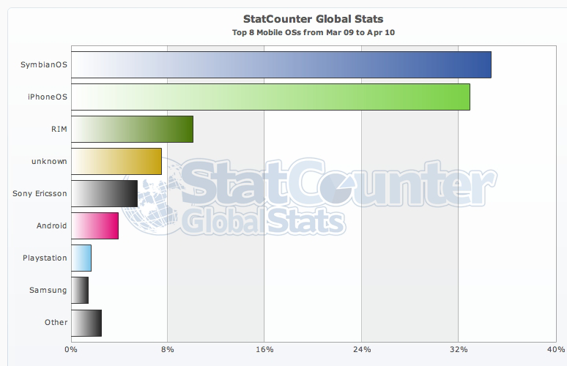

<http://gs.statcounter.com/#mobile_os-ww-monthly-200911-2010014>

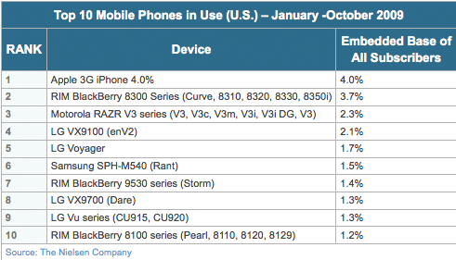

<http://blog.nielsen.com/nielsenwire/online_mobile/top-mobile-phones-sites-and-brands-for-2009/>

Browser use on phones:

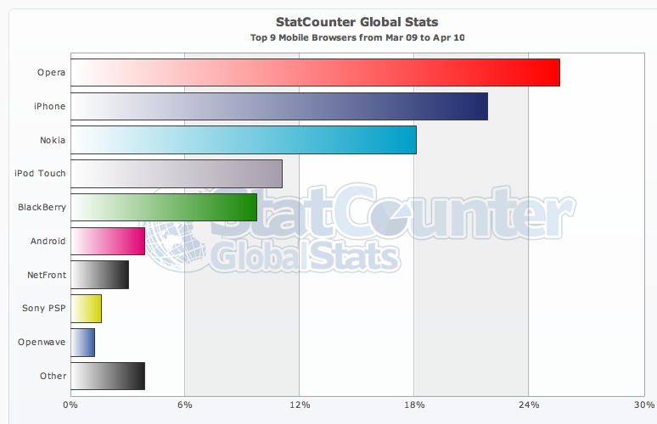

<http://gs.statcounter.com/#mobile_browser-ww-monthly-200911-2010014>

**List of supported Cell Phones by Opera browser:**

* Alcatel, Audiovox, Benq-Siemens, BlackBerry, LG, Motorola, NEC, Nokia, O2, Orange, Palm, Panasonic, Pantech, Philips, Qtek
* Cingular,Dopod, Fly, Generic, HTC, Sagem, Samsung, Sanyo, Sharp, Siemens, Sony Ericsson, T-Mobile, i-mate, Acer n311, Benq, P50, Grundig GR980, GSPDA Jasper S20,
* HP iPAQ 514, HP iPAQ hx2490, I-Mobile 901, Innostream Inno 55, Mitac Mio A701, Sendo S600, Sendo X, Sony CLIE PEG-UX50,
* Toshiba G900, Toshiba VM4050, Virgin Lobster 700TV, VKMobile VK2020, Vodafone VPA Compact, Voxtel VS600, Voxtel W210. Infact most phones with GPRS.

**What screen size do we design for?**

The design of the site will have to adapt to a myriad of screen sizes. The main difference between designs for a desktop vs. a mobile device is that desktop resolutions are more horizontal (1024x768) while a mobile device is more vertical (360x480). Therefore, the design must be simple and have the ability to ‘stack’ which means each piece of navigation will rest on top of the other in a vertical pattern. Text should be kept to a minimum and images will have to be sparse.

* The Blackberry 9700 uses a display size of 360x480 pixels
* The Sony Satio uses a display display size of 360x640 pixels
* The Sony Ericsson Aino has a 240x430 pixel screen
* The iPhone has a 320×480 pixel screen
* The HTC Touch Pro has a 480×640 pixel screen
* The Palm Pre has a 320×480 pixel screen
* The BlackBerry Storm has a 360×480 pixel screen
* Actual measurements of my Blackberry screen: 192 x 144
* Actual measurements of my iPhone screen: 192 x 240

**Screen Sizes**

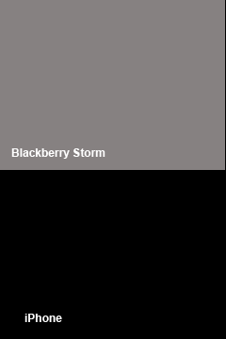

**Do you auto-detect and force a phone user to the mobile site?**

According to most design theories for mobile sites, you should let your users choose between viewing the full site and switching into the mobile site. In practice, this hardly seams to be used with most sites detecting that you are on a phone and sending you off to the mobile site automatically. Since the full radisys.com site is not designed even remotely for mobile users, this is the route that I would suggest taking.

**Sites to see/compare**

* Walmart
  + <http://www.walmart.com>
  + <http://mobile.walmart.com>
* CNET
  + <http://www.cnet.com>
  + <http://iphone.cnet.com> - iPhone only? Check on BB
* CBS
  + <http://www.cbsbews.com>
  + http://iphone. cbsbews.com
* Amazon
  + <http://www.amazon.com>
  + http://iphone. cbsbews.com
* Walgreens
  + <http://www.walgreens.com/>
  + <http://www.walgreens.com/> - interesting, Walgreens forces you into mobile